3.15 Generator Choosing
The most important part of any wind power producing device is the generator. Connected to the blades, it’s the part that converts rotational motion into electricity through the use of magnetic fields.
If you’re building your own wind powered generator, chances are your goal will be to build a dc type power generator. This means that the power that your wind turbine will produce will be direct current. This is the same type of current that’s used in any battery system. This is an advantage for a few different reasons. The first, and arguably most important of these reasons, is that of storage. DC power can be easily, and relatively cheaply stored for later use with a battery system. If your power requirements are low, yet your wind generator is producing a lot of power, you can save it for later use. With an ac power system, this is much more difficult and expensive to do.
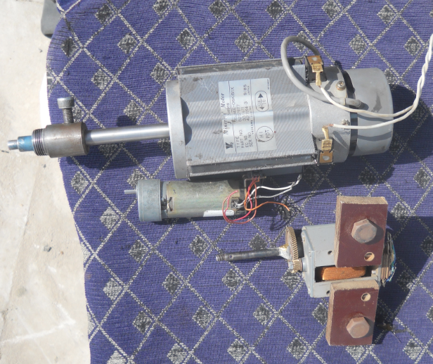
The second advantage of producing dc power is that of lower initial motor/generator costs. DC permanent magnet motors and generators are fairly inexpensive and come in a wide variety of configurations. There are a wide range of different motor speeds, amperages, and operating voltages that are available. Because of this variety, it’s easier to increase your turbines efficiency by matching your needs to your operating parameters.
There are a few different places you can look when trying to find a dc permanent magnet motor when you’re building your wind generator. If you’re trying to find a free one, one of the most popular sources used to be home treadmills. The motors that powered most of them were dc permanent magnet motors. If you look through your local penny pincher, classifieds, or even craigslist ads, you can often find these treadmills available for free just for taking them off the owner’s hands. The added advantage to acquiring a motor this way is that you’ll get a lot of extra parts that could help you build your wind turbine.
But with the recent increase in oil and energy prices, and the fact that thousands of people are now building their own power generators, finding these free motors is getting harder to do. You’re often better off getting one from eBay or a surplus supply house. The cost of buying one is often very low, and you can get a brand new motor complete with hubs for much less than the hassle involved with finding a free one.
Since you’re probably using a set of plans to build your own wind turbine, you’ve probably got a good idea of what need to use when choosing a permanent magnet dc motor/generator. You’ll want a motor that has a higher voltage, higher current, and a lower rpm. This will allow you to generate much more power at a lower speed (rpm). The advantage of this is that running your wind generator at slower speeds lets it last longer. There is much less wear and tear at slower speed than higher ones. This helps your reliability, and over the long term, substantially lowers your operating costs. Less maintenance and more power production is always a good thing.
3.15.1 Generator Cooling System :

Generators need cooling while they work. On most turbines this is accomplished by encapsulating the generator in a duct, using a large fan for air cooling, but a few manufacturers use water cooled generators. Water cooled generators may be built more compactly, which also gives some electrical efficiency advantages, but they require a radiator in the nacelle to get rid of the heat from the liquid cooling system.

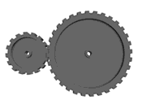3.16 Gearbox :

The WindCube
impeller directly drives its generator, eliminating the need for the gearbox used in conventional wind turbines. In addition to reducing
initial cost, eliminating the gearbox reduces maintenance costs and enhances reliability as gearboxes are failure prone.

